Using an existing CCTV network for *crowd management, **crime prevention, and **work monitoring
*Rajdeep singh , Chirag, Rahul, Khushi

^{CSE(R&AI)}
CHANDIGARH GROUP OF COLLEGE , MMOHALI

ABSTRACT
Anomaly detection in video surveillance has become a sophisticated field of study, attracting considerable attention from researchers. There is a growing demand for smart systems that can automatically spot unusual events in real-time video streams. As a result, various techniques have been introduced to create effective models aimed at improving public safety. Many reviews have examined different facets of anomaly detection, such as network anomalies, financial fraud, and the analysis of human behavior. The use of deep learning has shown remarkable effectiveness across numerous areas of computer vision. Importantly, the swift progress of generative models has placed them at the forefront of modern methodologies. This paper aims to provide a comprehensive review of deep learning-based approaches for detecting anomalies in video. These methods are categorized according to their goals and learning metrics.

Closed-Circuit Television (CCTV) systems play a vital role in contemporary security frameworks, providing uninterrupted surveillance that serves both as a deterrent and an essential mechanism for monitoring and gathering evidence. In contrast to human security personnel, who may experience fatigue and have limitations in their field of vision, CCTV cameras deliver reliable, round-the-clock observation of critical locations. They address deficiencies in existing security measures by facilitating real-time monitoring and recording of incidents for subsequent analysis, thereby ensuring that potential security threats are identified and managed more efficiently. This not only enhances the overall effectiveness of security measures but also diminishes the dependence on human oversight. The incorporation of Artificial Intelligence and Machine Learning (AIML) technologies into current CCTV systems offers a promising strategy to tackle significant challenges in urban settings. This initiative explores the utilization of AIML for crowd management, crime deterrence, and workplace oversight through CCTV infrastructure. In terms of crowd management, AIML allows for automated counting and density assessment of crowds, which aids in the effective distribution of resources during events and emergencies. For crime prevention, AIML algorithms process video feeds in real-time to identify suspicious behaviors and detect anomalies, thereby assisting law enforcement in taking proactive measures. Furthermore, AIML improves workplace monitoring by evaluating productivity indicators, ensuring adherence to safety regulations, and streamlining operational processes. The fusion of AIML with existing CCTV systems signifies a groundbreaking evolution in urban surveillance and management strategies, providing scalable solutions to a variety of urban challenges.

The use of current CCTV systems for efficient crowd management, crime prevention, and employee monitoring by applying artificial intelligence and machine learning (AI/ML) technologies. This strategy utilizes real-time video analytics to boost situational awareness, allowing for proactive responses to potential criminal activities while also enhancing workforce management. By combining AI/ML algorithms with existing surveillance systems, the proposed framework seeks to enhance safety and operational efficiency across different settings.

- INTRODUCTION

In today's world, where cities are growing and populations are booming, we face some pretty tough challenges when it comes to public safety and keeping things running smoothly. That's why it's become so important to make the most of what we already have. Take Closed-Circuit Television (CCTV) networks, for example. They started out as simple surveillance tools, but now, when we combine them with Artificial Intelligence (AI) and Machine Learning (ML), they turn into something much more powerful.

With these advancements, traditional CCTV systems can help us manage crowds in real-time, prevent crimes before they happen, and monitor workplaces more effectively—all with improved accuracy and efficiency. Thanks to AI and ML algorithms, these networks can spot unusual activities, recognize faces, analyze how crowded a space is, track movements, and even check if safety rules are being followed. This not only boosts security but also helps everyone make better decisions, whether in public or private sectors. Embracing AI-powered CCTV systems is a smart move toward creating smarter cities, safer neighborhoods, and more efficient workplaces, all while reducing the need for costly new infrastructure. 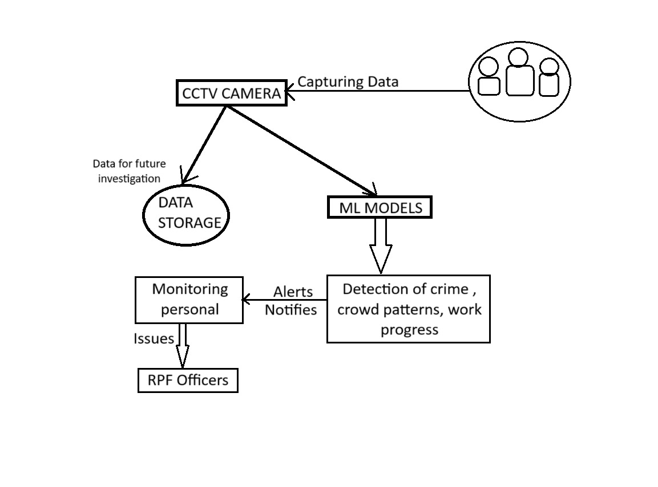
- A. METHODOLOGY USED IN CROWD
MANAGEMENT
1. Problem Identification
The primary problem addressed by this code is crowd counting and management. The application aims to:

Detect and count people in images, videos, or live camera feeds.
Provide real-time statistics and alerts for crowd thresholds.
Enable users to analyze crowd density for various use cases, such as event management, safety monitoring, or analytics.
2. Technology Selection
The code leverages the following technologies and frameworks:

YOLOv3 (You Only Look Once): A state-of-the-art object detection algorithm known for its speed and accuracy.
OpenCV: A computer vision library used for image and video processing.
Streamlit: A Python framework for building interactive web applications.
CUDA (if available): GPU acceleration for faster processing using NVIDIA GPUs.
Telegram API: For sending alerts when crowd thresholds are exceeded.
3. Data Processing and Model Integration
The methodology for integrating YOLOv3 into the application includes:

Model Loading:

The YOLOv3 weights (yolov3.weights) and configuration file (yolov3.cfg) are loaded using OpenCV's DNN module.
The COCO dataset class names (coco.names) are used to identify objects detected by the model.
Preprocessing:

Images and video frames are resized and normalized into a format compatible with YOLOv3 using cv2.dnn.blobFromImage.
Inference:

The YOLOv3 model processes the input data to detect objects (people in this case).
Non-Maximum Suppression (NMS) is applied to filter overlapping bounding boxes and retain the most confident detections.
Postprocessing:

Detected bounding boxes are drawn on the image or video frame.
The number of people detected is calculated and displayed.
4. Real-Time Processing
The application supports real-time processing through:

Live Camera Feed:

Frames are captured from the webcam, processed using YOLOv3, and displayed with detection results.
Statistics such as FPS, current count, and average count are updated in real-time.
File Uploads:

Users can upload images or videos for batch processing.
Processed results are displayed and made available for download.
5. Alert Mechanism
The code includes a Telegram alert system to notify users when a crowd threshold is exceeded:

Threshold Monitoring:

The user sets a threshold for the number of people detected.
If the count exceeds the threshold, an alert is triggered.
Telegram Integration:

The Telegram bot token and chat ID are used to send alerts via the Telegram API.
Alerts are sent in a thread-safe manner using Python's threading and queue modules.
6. User Interaction and Customization
The application provides an interactive interface for users to:

Adjust detection settings (e.g., confidence threshold, minimum person height, NMS threshold).
Choose between different presets optimized for various scenarios (e.g., crowded vs. sparse scenes).
Enable or disable Telegram alerts and configure alert thresholds.
7. Performance Optimization
The code includes several optimizations to improve performance:

GPU Acceleration:

If an NVIDIA GPU with CUDA support is available, the application uses it for faster processing.
A fallback to CPU is implemented if CUDA is unavailable.
Resolution Adjustment:

Users can adjust the resolution of the live camera feed to balance performance and accuracy.
Batch Processing:

For videos, frames are processed in batches, and progress is displayed using a progress bar.
8. Validation and Testing
The application includes mechanisms to handle errors and validate inputs:

Error Handling:
Errors during model loading, inference, or Telegram API calls are caught and displayed to the user.
Input Validation:
The application checks for missing or invalid Telegram credentials and notifies the user.
9. Documentation and User Guidance
The application provides detailed documentation and usage tips:

Features and tips are displayed in the sidebar and an expandable "About" section.
Users are guided on how to configure settings, use presets, and enable alerts.
10. Ethical Considerations
The application processes all data locally, ensuring user privacy:

No data is uploaded to external servers.
The application is designed for ethical use cases, such as safety monitoring and analytics.

B.Methodology for crime prevention
1. Problem Definition
The code aims to detect fights, weapons, and suspicious items in video streams or webcam feeds. It uses computer vision techniques to analyze frames in real-time and identify potential threats or aggressive behavior.

2. Technology Selection
The code leverages the following technologies:

YOLOv4-Tiny: A lightweight object detection model for real-time performance.
OpenCV: A computer vision library for image and video processing.
Streamlit: A Python framework for building interactive web applications.
Numpy: For numerical operations and array manipulations.
3. Model Initialization
The load_yolo_model function initializes the YOLOv4-Tiny model:

Weights File (yolov4-tiny.weights): Contains the pre-trained model weights.
Configuration File (yolov4-tiny.cfg): Defines the architecture of the YOLOv4-Tiny model.
Class Names File (coco.names): Contains the list of object classes the model can detect.
The model is configured to use the CPU for inference, but it can be extended to use a GPU if available.

4. Input Handling
The application allows users to choose between two input sources:

Webcam: Captures live video feed from the user's webcam.
Uploaded Video: Processes a video file uploaded by the user.
The input source is selected via a Streamlit sidebar.

5. Preprocessing
Each video frame is preprocessed before being passed to the YOLO model:

Blob Creation: The frame is resized, normalized, and converted into a blob using cv2.dnn.blobFromImage.
Model Input: The blob is set as the input to the YOLO model.
6. Object Detection
The YOLO model performs object detection on the preprocessed frame:

Bounding Boxes: The model outputs bounding boxes for detected objects.
Confidence Scores: Each detection is associated with a confidence score.
Non-Maximum Suppression (NMS): Overlapping bounding boxes are filtered using NMS to retain the most confident detections.
The detected objects are categorized into:

Weapons: Objects like knives, guns, pistols, and rifles.
Suspicious Items: Objects like backpacks and bags.
7. Fight Detection
The detect_fights function analyzes motion in the video to detect fights:

Frame Differencing: The difference between the current frame and the previous frame is calculated to detect motion.
Thresholding: A binary threshold is applied to highlight regions of motion.
Contour Analysis: Contours are extracted from the thresholded image to identify areas of significant motion.
Motion History: The motion history is analyzed to detect aggressive movements, which may indicate a fight.
8. Alert Generation
Alerts are generated based on the detections:

Weapon Detected: If a weapon is detected, an alert is generated with the weapon's label and bounding box.
Fight Detected: If aggressive motion is detected, a "Fight Detected" alert is generated.
9. Visualization
The draw_detections function visualizes the results:

Bounding Boxes: Drawn around detected objects with different colors for weapons, suspicious items, and other objects.
Labels: Displayed above each bounding box with the object's name and confidence score.
Alerts: Highlighted on the frame (e.g., "FIGHT DETECTED!" in red).
The processed frame is displayed in real-time using Streamlit's st.image.

10. Real-Time Processing
The application processes video frames in a loop:

Frames are read from the video source (webcam or uploaded file).
Each frame is passed through the detection and fight analysis pipeline.
The processed frame is displayed in real-time.
11. User Interaction
The application provides an interactive interface for users:

Settings Sidebar:
Adjust confidence and NMS thresholds.
Select the input source (webcam or uploaded video).
Real-Time Feedback:
Displays the processed video with detections and alerts.
12. Error Handling
The code includes basic error handling:

Missing Files: Checks for the existence of YOLO files (weights, cfg, names) and displays an error if they are missing.
Webcam Access: Notifies the user if the webcam cannot be accessed.
Uploaded File: Warns the user if no video file is uploaded.
13. Performance Optimization
YOLOv4-Tiny: A lightweight version of YOLOv4 is used for faster inference.
Background Subtraction: Used for motion detection to reduce computational overhead.
Streamlit Caching: The YOLO model is cached using @st.cache_resource to avoid reloading it on every run.
14. Output
The application provides the following outputs:

Processed Video: Displays the video with bounding boxes and alerts in real-time.
Alerts: Highlights detected weapons and fights on the video frame.

- RESULTS AND DISCUSSION

A.RESULT OF CROWD MANAGEMENTS :-



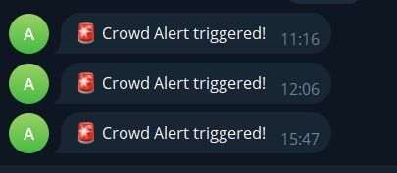This streamlight-based benefits from the Counter app to identify the Yolov3 object detection model accurately and count individuals in photos, videos and live camera feed, which benefits from showcasing real-time results with a delimitation box and confidence percentage. It provides customization settings (including Vishwas threshold and size parameters), many input methods and GPU acceleration for optimal performance. When activated, the Telegram notification system sends when the overload number exceeds the user-defined threshold, while maintaining a configured cold period between information. Treated output - including anotat images and videos - can be downloaded, and the interface provides live analyzes such as frame rate, current counting and sliding average.
With a strong error handling for model loading, credentials and hardware compatibility, this application acts
versatile solution for audience monitoring in different scenarios.

All paragraphs must be indented. All paragraphs must be justified, i.e. both left-justified and right-justified.

Sample image:-
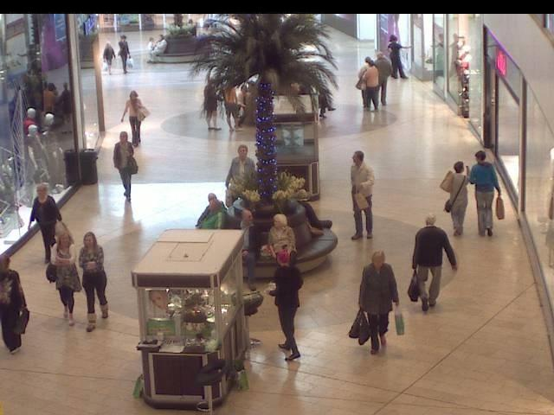

output

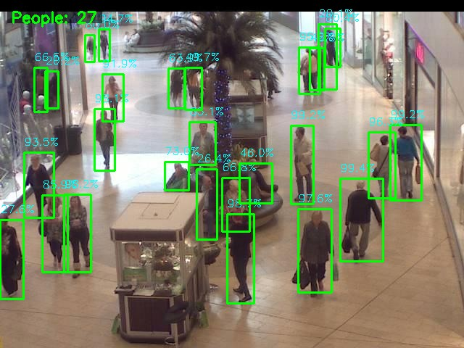

B.RESULT OF CRIME PREVENTION
1. Object Detection
The system detects objects in video frames using the YOLOv4-Tiny model:

Weapons: Detects objects like knives, guns, pistols, and rifles.
Suspicious Items: Detects objects like backpacks and bags.
Other Objects: Detects other objects based on the COCO dataset classes.
Output:

Bounding boxes are drawn around detected objects.
Labels and confidence scores are displayed above each bounding box.
2. Fight Detection
The system analyzes motion in the video to detect fights:

Motion Analysis:
Uses frame differencing and contour analysis to detect areas of significant motion.
Tracks motion history to identify aggressive movements.
Fight Alerts:
If aggressive motion is detected, the system generates a "Fight Detected" alert.Output:

A red bounding box is drawn around the area of aggressive motion.
The text "FIGHT DETECTED!" is displayed on the video frame.
3. Real-Time Video Processing
The system processes video frames in real-time:

Webcam Feed:
Captures live video from the user's webcam.
Displays the processed video with detections and alerts in real-time.
Uploaded Video:
Processes a video file uploaded by the user.
Displays the processed video frame by frame.
Output:

The processed video is displayed in the Streamlit interface with bounding boxes, labels, and alerts.
4. User Interaction
The system provides an interactive interface for users:

Input Source:
Users can choose between a webcam feed or an uploaded video file.
Settings:
Users can adjust the confidence threshold and NMS (Non-Maximum Suppression) threshold via the sidebar.
Output:

Users can customize the detection settings to optimize performance for different scenarios.
5. Alerts
The system generates alerts based on detections:

Weapon Detected:
If a weapon is detected, an alert is generated with the weapon's label and bounding box.
Fight Detected:
If aggressive motion is detected, a "Fight Detected" alert is generated.
Output:

Alerts are displayed visually on the video frame.
6. Performance Metrics
The system processes video frames in a loop and provides real-time feedback:

Frame Rate:
The system processes frames as quickly as possible, depending on the hardware capabilities.
Motion Level:
The intensity of motion is calculated and used to detect fights.
Output:

The processed video is displayed with real-time updates.
7. Error Handling
The system includes basic error handling:

Missing Files:
Displays an error if the YOLO weights, configuration, or class names file is missing.
Webcam Access:
Displays an error if the webcam cannot be accessed.
Uploaded File:
Displays a warning if no video file is uploaded.
Output:

Error messages are displayed in the Streamlit interface.
Example Results
Scenario 1: Weapon Detection
Input: A video of a person holding a knife.
Output:
A red bounding box is drawn around the knife.
The label "knife" and confidence score are displayed above the bounding box.
Scenario 2: Fight Detection
Input: A video of two people fighting.
Output:
A red bounding box is drawn around the area of aggressive motion.
The text "FIGHT DETECTED!" is displayed on the video frame.
Scenario 3: Suspicious Item Detection
Input: A video of a person carrying a backpack.
Output:
An orange bounding box is drawn around the backpack.
The label "backpack" and confidence score are displayed above the bounding box.
Summary of Results
Object Detection:
Detects weapons, suspicious items, and other objects in real-time.
Fight Detection:
Identifies aggressive motion and generates alerts for fights.
Real-Time Processing:
Processes video frames from a webcam or uploaded video in real-time.
Interactive Interface:
Allows users to customize detection settings and view results interactively.
Alerts:
Generates visual alerts for detected weapons and fights.

- CONCLUSION
The integration of Artificial Intelligence and Machine Learning with traditional CCTV systems marks a significant advancement in video surveillance, enabling real-time anomaly detection and enhancing public safety. By automating tasks such as crowd analysis, crime detection, and workplace monitoring, AI/ML technologies overcome the limitations of human oversight and conventional surveillance methods. The use of deep learning techniques, particularly generative models, has proven highly effective in identifying unusual patterns and behaviors in video feeds. This approach not only improves situational awareness and response times but also supports efficient resource allocation in complex urban environments. Overall, the proposed AI/ML-driven surveillance framework offers a scalable and intelligent solution for addressing modern security and operational challenges.

